

Dhaka International University

Computer Graphics, 0613-404

Interactive 3D Bedroom Environment Using Python OpenGL
Student Name: K M Shihab Jami
Student ID: 01
Development Environment: Visual Studio Code
Programming Language: Python
Graphics API: OpenGL
Source code: https://github.com/shihab-no-one/Sharing/blob/main/bedroom.py

1. Introduction
The objective was to create an interactive 3D bedroom environment using the concepts taught in class. I developed this project as the final task for the Computer Graphics course. My objective was to create an interactive 3D bedroom environment using the concepts I learned throughout the course.
I created a bedroom containing static objects such as a bed, table, lamp, floor, walls and ceiling. I also implemented a first-person camera that allows me to walk around and look around the room. In addition, I implemented the three required lighting types: directional light, point light and spot light.
I developed the project in Visual Studio Code using Python, OpenGL and GLFW. After installing the required packages, I ran the program through the terminal and explored the final environment inside an OpenGL window.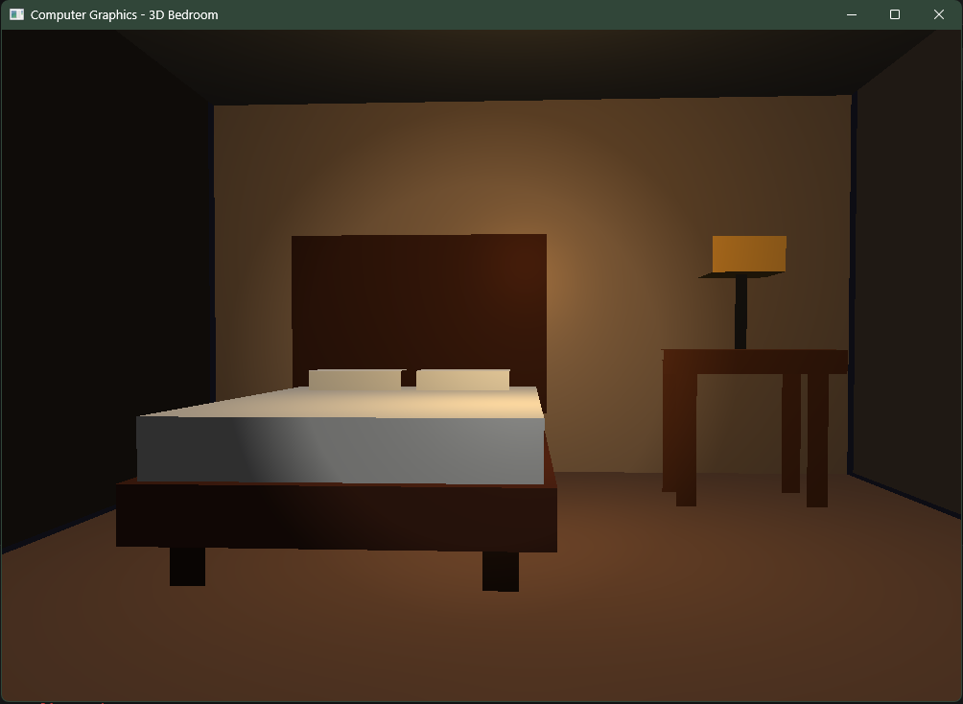

2. Objectives
My main objectives for this project were to:
- Create a 3D bedroom using basic geometric objects.
- Implement a bed and table as static objects.
- Add a first-person camera for walking and looking around.
- Implement directional, point and spot lighting.
- Use OpenGL shaders and 3D transformations.
- Run and test the environment through the terminal.

3. Tools and Technologies
Tool | Purpose
Python | Main programming language
OpenGL | 3D rendering
PyOpenGL | OpenGL functions in Python
GLFW | Window and keyboard/mouse input
PyGLM | Vector and matrix calculations
NumPy | Vertex data
Visual Studio Code | Development
Terminal | Running the program
I used Python as the main programming language and OpenGL for rendering the 3D environment. I used GLFW to create the OpenGL window and handle keyboard and mouse input. I also used PyGLM for camera and matrix calculations and NumPy for managing vertex data.
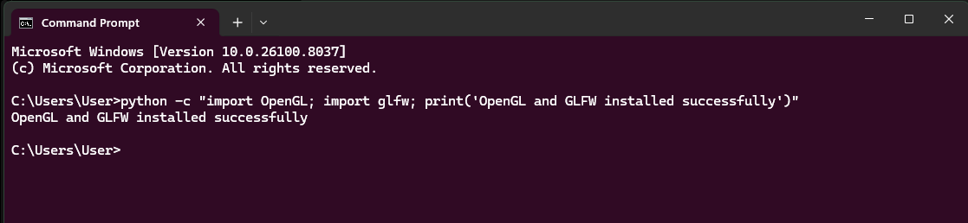

4. 3D Bedroom Implementation
I created the bedroom using basic cube-shaped 3D geometry. I reused the same cube and changed its scale and position to create different parts of the environment.
I created the floor, walls and ceiling to form the room. I built the bed using a bed frame, mattress, pillows, headboard and legs. I created the table using a tabletop and legs, and I also added a simple lamp to the environment.
I used VAO and VBO to store and manage the vertex data. I also included surface normals because they are required for the lighting calculations.
I used the model matrix to translate and scale each object to its required position and size.

5. Camera System
I implemented a first-person camera based on the camera example provided by my instructor.
The camera uses position, front and up vectors. I used the mouse to control the viewing direction and the keyboard to control movement.
Control | Function
W | Move forward
S | Move backward
A | Move left
D | Move right
Mouse | Look around
1 | Directional light
2 | Point light
3 | Spot light
ESC | Exit
I used the glm.lookAt() function to generate the view matrix. I also used perspective projection so that objects farther away appear smaller.

6. Lighting
I implemented three different lighting techniques as required by the assignment.

Directional Light
I used directional light to represent a distant light source such as sunlight. Its direction remains constant throughout the room, and I did not apply distance attenuation to it.

Point Light
I placed a point light at a specific location in the bedroom. It emits light in all directions, and its intensity decreases as the distance from the light increases.

Spot Light
I implemented a spot light that produces a focused cone of illumination. It uses a position, direction and cutoff angles. I connected the spotlight with the camera direction so that I can point the light around the room while exploring the environment.
I performed the lighting calculations inside the GLSL fragment shader using ambient, diffuse and specular components.

7. Shader and Rendering Pipeline
I used vertex and fragment shaders for rendering the environment.
The vertex shader transforms the object vertices using the model, view and projection matrices. It also passes the surface normal and fragment position to the fragment shader.
The fragment shader calculates the final color using the object's color and the selected light source.
I used the standard Model-View-Projection pipeline:
Model → View → Projection
This process converts the 3D objects in the bedroom into the final image displayed in the OpenGL window.

8. Installation and Execution
I developed the project in Visual Studio Code and installed the required packages through the terminal.
I used the following command:
pip install glfw PyOpenGL PyGLM numpy
I saved the main Python file as:
bedroom.py
I then opened the terminal in the project directory and ran the program using:
python bedroom.py
After running the command, the OpenGL window appeared with my 3D bedroom environment.
I tested the environment by walking around using the keyboard, looking around with the mouse and switching between the three lighting modes.
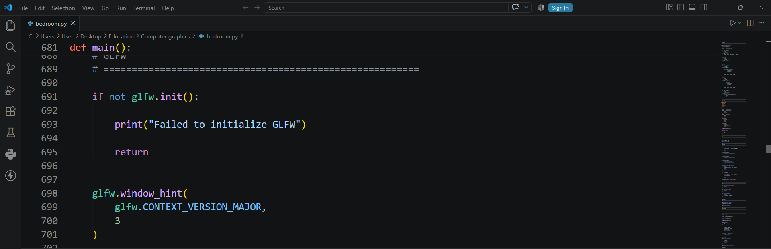

9. Final Environment
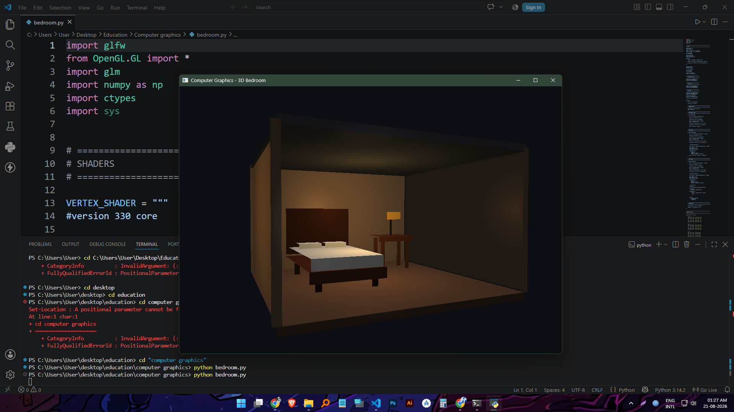
The screenshot shows my completed bedroom environment running inside the OpenGL window. I was able to explore the scene using the camera controls and observe the objects and lighting from different viewpoints.

10. Results and Discussion
I successfully combined the main requirements of the assignment into one interactive environment. I created static 3D objects, including the required bed and table.
I implemented a first-person camera that allows me to move around the bedroom and view the objects from different directions. The perspective projection gives the environment a proper sense of depth.
I also tested the three lighting modes and observed their different effects on the objects. Directional lighting provides general illumination, point lighting creates a localized light source, and spot lighting produces focused illumination.
Through this project, I gained practical experience with OpenGL concepts such as VAO, VBO, shaders, transformations, surface normals, camera movement and lighting.

